Charlotte’s Web Site Annual Report
2013
Elizabeth Nofs
Charlotte’s Web Site
5/13/2013

From the Farm to Your Table: That’s Freshe!
Charlotte's Web Site
123 Main Street
Brighton MI 48116
Friday, August 20, 2013

Dear Friends and Clients,

Welcome to Charlotte's Website. Our “Farm Fresh” approach has been profitable this year. This Quarterly Report –focuses on our - product sales and our new product releases.

Sincerely,
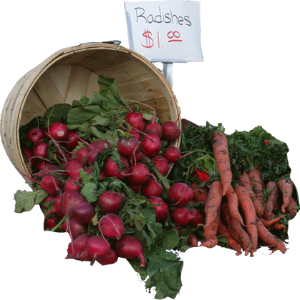
Elizabeth

Products In Stock
Fresh Fruits
Apples
Aveocados
Kiwis
Pears
Fresh Vegetables
Chives
Tomatoes
- Apples, Fruit, 25
- Bananas, Fruit, 12
- Kiwi, Fruit, 14
- Peppers, Veggie, 50
- Tomato, Fruit, 10
  - Roma
  - Better Boy

Sample Heading
Lorem ipsum dolor sit amet, consectetur adipisicing elit, sed do eiusmod tempor incididunt ut labore et dolore magna aliqua. Ut enim ad minim veniam, quis nostrud exercitation ullamco laboris nisi ut aliquip ex ea commodo consequat. Duis aute irure dolor in reprehenderit in voluptate velit esse cillum dolore eu fugiat nulla pariatur. Excepteur sint occaecat cupidatat non proident, sunt in culpa qui officia deserunt mollit anim id est laborum

Sample Heading
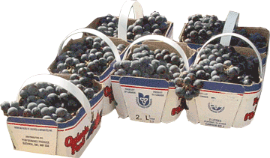
Lorem ipsum dolor sit amet, consectetur adipisicing elit, sed do eiusmod tempor incididunt ut labore et dolore magna aliqua. Ut enim ad minim veniam, quis nostrud exercitation ullamco laboris nisi ut aliquip ex ea commodo consequat. Duis aute irure dolor in reprehenderit in voluptate velit esse cillum dolore eu fugiat nulla pariatur. Excepteur sint occaecat cupidatat non proident, sunt in culpa qui officia deserunt mollit anim id est laborum

New Products in Production
Winesap Apples | Stayman, also known as Winesap, has a smooth, thick greenish-yellow skin is covered with flushes of red and dark red. Inside, it has firm, tender, finely-textured juicy, crisp yellowish-green flesh with a tangy, spicy taste. People love to make pies and cider with these apples. | 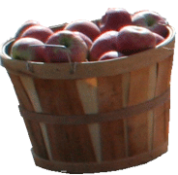
Peanut Pumpkins | Peanut Pumpkins are also known as Galeuse d'Eysines, Courge Brodee Galeuse, and warted sugar marrow. They are about 11.5" in diameter and 6.5" inches high. They weigh about 18 pounds. | 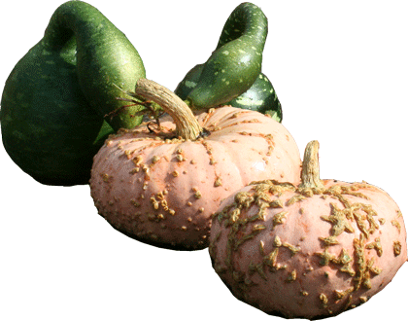
Turban Squash | A winter squash with amazing coloration and shapes. They are about 3” in diameter and 4.5” high. They weigh about half a pound. | 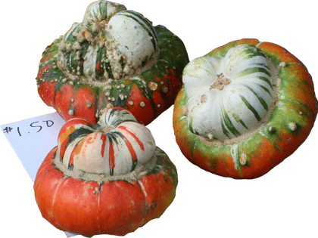
Sunflower Seeds | Organic sunflower seeds are a rich source of vitamins and minerals. In addition to linoleic acid (an essential fatty acid), sunflower seeds are also an excellent source of dietary fiber, some amino acids (especially tryptophan), Vitamin E, B Vitamins and minerals such as copper, manganese, potassium, magnesium, iron, phosphorus, selenium, calcium and zinc. Additionally, they are rich in cholesterol-lowering phytosterols. | 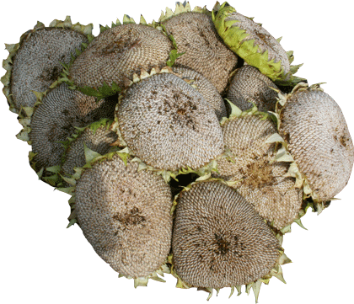

Apples Sales Revenue
Initial | 200
Increment | 20
Date | Product | Net | Quantity | Revenue
February 1, 2013 | Apples | $ 3.50 | 200 | $ 700.00
February 2, 2013 | Apples | $ 3.50 | 220 | $ 770.00
February 3, 2013 | Apples | $ 3.50 | 240 | $ 840.00
February 4, 2013 | Apples | $ 3.50 | 260 | $ 910.00
February 7, 2013 | Apples | $ 3.50 | 280 | $ 980.00
February 8, 2013 | Apples | $ 3.50 | 300 | $ 1,050.00
February 9, 2013 | Apples | $ 3.50 | 320 | $ 1,120.00
February 10, 2013 | Apples | $ 3.50 | 340 | $ 1,190.00
February 11, 2013 | Apples | $ 3.50 | 360 | $ 1,260.00
February 14, 2013 | Apples | $ 3.50 | 380 | $ 1,330.00
February 15, 2013 | Apples | $ 3.50 | 400 | $ 1,400.00
February 16, 2013 | Apples | $ 3.50 | 420 | $ 1,470.00
February 17, 2013 | Apples | $ 3.50 | 440 | $ 1,540.00
February 18, 2013 | Apples | $ 3.50 | 460 | $ 1,610.00
February 21, 2013 | Apples | $ 3.50 | 480 | $ 1,680.00
February 22, 2013 | Apples | $ 3.50 | 500 | $ 1,750.00
February 23, 2013 | Apples | $ 3.50 | 520 | $ 1,820.00
February 24, 2013 | Apples | $ 3.50 | 540 | $ 1,890.00
February 25, 2013 | Apples | $ 3.50 | 560 | $ 1,960.00
February 28, 2013 | Apples | $ 3.50 | 580 | $ 2,030.00
 |  |  | 7,800 | $ 27,300.00

Peanut Pumpkin Sales Revenue
Initial | 300
Increment | 30
Date | Product | Net | Quantity | Revenue
February 1, 2013 | Peanut Pumpkins | $ 2.50 | 300 | $ 750.00
February 2, 2013 | Peanut Pumpkins | $ 2.50 | 330 | $ 825.00
February 3, 2013 | Peanut Pumpkins | $ 2.50 | 360 | $ 900.00
February 4, 2013 | Peanut Pumpkins | $ 2.50 | 390 | $ 975.00
February 7, 2013 | Peanut Pumpkins | $ 2.50 | 420 | $ 1,050.00
February 8, 2013 | Peanut Pumpkins | $ 2.50 | 450 | $ 1,125.00
February 9, 2013 | Peanut Pumpkins | $ 2.50 | 480 | $ 1,200.00
February 10, 2013 | Peanut Pumpkins | $ 2.50 | 510 | $ 1,275.00
February 11, 2013 | Peanut Pumpkins | $ 2.50 | 540 | $ 1,350.00
February 14, 2013 | Peanut Pumpkins | $ 2.50 | 570 | $ 1,425.00
February 15, 2013 | Peanut Pumpkins | $ 2.50 | 600 | $ 1,500.00
February 16, 2013 | Peanut Pumpkins | $ 2.50 | 630 | $ 1,575.00
February 17, 2013 | Peanut Pumpkins | $ 2.50 | 660 | $ 1,650.00
February 18, 2013 | Peanut Pumpkins | $ 2.50 | 690 | $ 1,725.00
February 21, 2013 | Peanut Pumpkins | $ 2.50 | 720 | $ 1,800.00
February 22, 2013 | Peanut Pumpkins | $ 2.50 | 750 | $ 1,875.00
February 23, 2013 | Peanut Pumpkins | $ 2.50 | 780 | $ 1,950.00
February 24, 2013 | Peanut Pumpkins | $ 2.50 | 810 | $ 2,025.00
February 25, 2013 | Peanut Pumpkins | $ 2.50 | 840 | $ 2,100.00
February 28, 2013 | Peanut Pumpkins | $ 2.50 | 870 | $ 2,175.00
 |  |  | 11,700 | $ 29,250.00

Turban Squash Sales Revenue
Initial | 100
Increment | 15
Date | Product | Net | Quantity | Revenue
February 1, 2013 | Turbin Squash | $ 1.50 | 100 | $ 150.00
February 2, 2013 | Turbin Squash | $ 1.50 | 115 | $ 172.50
February 3, 2013 | Turbin Squash | $ 1.50 | 130 | $ 195.00
February 4, 2013 | Turbin Squash | $ 1.50 | 145 | $ 217.50
February 7, 2013 | Turbin Squash | $ 1.50 | 160 | $ 240.00
February 8, 2013 | Turbin Squash | $ 1.50 | 175 | $ 262.50
February 9, 2013 | Turbin Squash | $ 1.50 | 190 | $ 285.00
February 10, 2013 | Turbin Squash | $ 1.50 | 205 | $ 307.50
February 11, 2013 | Turbin Squash | $ 1.50 | 220 | $ 330.00
February 14, 2013 | Turbin Squash | $ 1.50 | 235 | $ 352.50
February 15, 2013 | Turbin Squash | $ 1.50 | 250 | $ 375.00
February 16, 2013 | Turbin Squash | $ 1.50 | 265 | $ 397.50
February 17, 2013 | Turbin Squash | $ 1.50 | 280 | $ 420.00
February 18, 2013 | Turbin Squash | $ 1.50 | 295 | $ 442.50
February 21, 2013 | Turbin Squash | $ 1.50 | 310 | $ 465.00
February 22, 2013 | Turbin Squash | $ 1.50 | 325 | $ 487.50
February 23, 2013 | Turbin Squash | $ 1.50 | 340 | $ 510.00
February 24, 2013 | Turbin Squash | $ 1.50 | 355 | $ 532.50
February 25, 2013 | Turbin Squash | $ 1.50 | 370 | $ 555.00
February 28, 2013 | Turbin Squash | $ 2.50 | 385 | $ 962.50
 |  |  | 4,850 | $ 7,660.00

Turban Squash Sales Revenue
Initial | 100
Increment | 10
Date | Product | Net | Quantity | Revenue
February 1, 2013 | Sunflower Seeds | $ 2.25 | 100 | $ 225.00
February 2, 2013 | Sunflower Seeds | $ 2.25 | 110 | $ 247.50
February 3, 2013 | Sunflower Seeds | $ 2.25 | 120 | $ 270.00
February 4, 2013 | Sunflower Seeds | $ 2.25 | 130 | $ 292.50
February 7, 2013 | Sunflower Seeds | $ 2.25 | 140 | $ 315.00
February 8, 2013 | Sunflower Seeds | $ 2.25 | 150 | $ 337.50
February 9, 2013 | Sunflower Seeds | $ 2.25 | 160 | $ 360.00
February 10, 2013 | Sunflower Seeds | $ 2.25 | 170 | $ 382.50
February 11, 2013 | Sunflower Seeds | $ 2.25 | 180 | $ 405.00
February 14, 2013 | Sunflower Seeds | $ 2.25 | 190 | $ 427.50
February 15, 2013 | Sunflower Seeds | $ 2.25 | 200 | $ 450.00
February 16, 2013 | Sunflower Seeds | $ 2.25 | 210 | $ 472.50
February 17, 2013 | Sunflower Seeds | $ 2.25 | 220 | $ 495.00
February 18, 2013 | Sunflower Seeds | $ 2.25 | 230 | $ 517.50
February 21, 2013 | Sunflower Seeds | $ 2.25 | 240 | $ 540.00
February 22, 2013 | Sunflower Seeds | $ 2.25 | 250 | $ 562.50
February 23, 2013 | Sunflower Seeds | $ 2.25 | 260 | $ 585.00
February 24, 2013 | Sunflower Seeds | $ 2.25 | 270 | $ 607.50
February 25, 2013 | Sunflower Seeds | $ 2.25 | 280 | $ 630.00
February 28, 2013 | Sunflower Seeds | $ 2.25 | 290 | $ 652.50
 |  |  | 3,900 | $ 8,775.00

Turban Squash Sales Revenue
Total Sales | $ 72,985.00
Total Units Sold | 28,250
Date | Product | Revenue
February 1, 2013 | All New Products | $ 1,825.00
February 2, 2013 | All New Products | $ 2,015.00
February 3, 2013 | All New Products | $ 2,205.00
February 4, 2013 | All New Products | $ 2,395.00
February 7, 2013 | All New Products | $ 2,585.00
February 8, 2013 | All New Products | $ 2,775.00
February 9, 2013 | All New Products | $ 2,965.00
February 10, 2013 | All New Products | $ 3,155.00
February 11, 2013 | All New Products | $ 3,345.00
February 14, 2013 | All New Products | $ 3,535.00
February 15, 2013 | All New Products | $ 3,725.00
February 16, 2013 | All New Products | $ 3,915.00
February 17, 2013 | All New Products | $ 4,105.00
February 18, 2013 | All New Products | $ 4,295.00
February 21, 2013 | All New Products | $ 4,485.00
February 22, 2013 | All New Products | $ 4,675.00
February 23, 2013 | All New Products | $ 4,865.00
February 24, 2013 | All New Products | $ 5,055.00
February 25, 2013 | All New Products | $ 5,245.00
February 28, 2013 | All New Products | $ 5,820.00
 |  | $ 72,985.00

